Jackson Heart Study Protocol

Manual 3

Blood Pressure

Visit 3

Version 3.0

October 14, 2008

For Copies, Please Contact:

Jackson Heart Study Coordinating Center
Jackson Medical Mall
350 W. Woodrow Wilson Dr.
Jackson, MS 39213

FORWARD

This manual is one of a series of protocols and manuals of operation for the Jackson Heart Study (JHS). The complexity of the JHS requires that a sizeable number of procedures be described, thus this rather extensive list of materials has been organized into the set of manuals listed below. Manual 1 provides the background, organization, and general objectives of the JHS Study. Manuals 2, 3, and 4 describe the operation of the Cohort Procedures, Blood Pressure and Central Laboratory and Specimen Repository Components of the study. Manuals 5 and comprise Electrocardiography and Magnetic Resonance Image studies, respectively. . Manual 7 comprises of Morbidity and Mortality Classifications. Manual 8 articulates the quality assurance and control activities of JHS Examination 3 components. Quality control includes activities that are designed to assure quality of data, which take place prior to the collection of data. Quality control relates to efforts during this study to monitor the quality of data. Detailed Manuals of operation for specific procedures, including those for Blood Pressure and Quality Control, make up Manual 4 and 5. The Data Management System is described in Manual 9.

JHS Study Protocols and Manuals of Operation

MANUAL TITLE

- General Description and Study Management

- Cohort Component Procedures

- Blood Pressure

- The Central Laboratory and Specimen Repository

- Electrocardiography

- Magnetic Resonance Imaging

- Morbidity and Mortality

- Quality Control

- Data Management

Manual 3 Blood Pressure

TABLE OF CONTENTS

1.0
Sitting Blood Pressure Protocol
1.1 Introduction 1
1.2 Standardized Clinic Procedures 1
1.3 Description of the Equipment 1
1.4 Blood Pressure Measurement Instructions 1
1.5 Staff Preparation for Participant Visit 1
1.6 Measurement Procedures Error! Bookmark not defined.
1.7 Procedure for Changing the Peak Inflation Level Error! Bookmark not defined.
1.8 Reporting the Blood Pressure Results to the Participant Error! Bookmark not defined.
1.9 Stopping Rules for Elevated Blood Pressure 2
1.10 Sitting Blood Pressure Training and Certification 3
1.11 Quality Control 3
1.12 Technician Training and Quality Control 4
1.13 Equipment Maintenance 4
1.14 Referral of Hypertensives 4

2.0 Sitting Blood Pressure: Omron
2.1 Purpose 9
2.2 Equipment 5
2.3 Exclusions 5
2.4 Set-Up Procedure 5
2.5 Procedure 6
2.6 Tips for Ankle-Arm Measurements 13
2.7 Quality Assurance 8

3.0 self-monitored Blood Pressure Error! Bookmark not defined.
3.1 Introduction and Equipment Error! Bookmark not defined.
3.2 Preparation in Advance of Clinic Visit Error! Bookmark not defined.
3.3 Participant Instructions Error! Bookmark not defined.

3.4 Participant SMBP Follow Up

Manual 3. Blood Pressure

APPENDICES
Appendix 1 Maintenance for Standard Sphygmomanometer A-1
Appendix 2 Maintenance for Omron HEM907XL Blood Pressure Monitor A-2
Appendix 3 Checklist for Biannual Observation of BP Technicians A-3
Appendix4 Monthly Log for Sitting BP Station A-4

Appendix 5 Form for Recording Simultaneous BP Observation on a Volunteer by
Two Technicians A-5
Appendix 6 JHS Omron A-6
Appendix 7 Omron Instruction Manual: Model HEM907XL
Appendix 8 Omron Instruction Manual: HEM-780

Appendix 9 Self Monitored Blood Pressure Teaching
Manual 3. Blood Pressure

TABLES
Table 1. Determination of Cuff Size Based on Arm Circumferenc Error! Bookmark not defined.

Table 2. Classification Of Blood Pressure for Adults
Error! Bookmark not defined.

Table 3. Medical Care Referral Guidelines For Blood Pressure Based On
Initial Measurements
Error! Bookmark not defined.
Table 4. Determination Of Cuff Size Based On Arm Circumference 5

Table 5. Omron HEM-780 Error Codes, Causes and Solutions
Error! Bookmark not defined.

Table 6. Omron HEM-780 Troubleshooting Tips
Error! Bookmark not defined.

FIGURES

Figure 1. Changing The Peak Inflation Level On Paper FormsError! Bookmark not defined.

1.0 Sitting Blood Pressure Protocol

Introduction

As blood pressure rises, so does risk of ischemic heart disease and its complications. The range of normal blood pressures is wide. Even within the "normal" range, risk increases as the upper limits are approached. Usually, blood pressures are expressed as systolic pressure/diastolic pressure; values exceeding 140/90 mmHg are considered to be hypertensive for adults. Classification and staging of hypertension are more precise where systolic rather than diastolic is the principle criterion. Both systolic and diastolic blood pressure elevations are associated with increasing risk for cardiovascular disease. Middle-aged persons with a diastolic blood pressure of 90-104 mmHg (so-called "mild" hypertension) have a risk of heart attack that is about 70 percent higher than that of persons with a diastolic pressure under 80 mmHg (optimal value). Persons with a diastolic blood pressure exceeding 104 mmHg (moderately severe to severe hypertension) have a risk more than twice that of those with a normal value. Hypertension is an especially strong risk factor for stroke and, to a lesser extent, for peripheral vascular disease. Most of the knowledge of the consequences of high blood pressure arises from studies of sitting arm blood pressure, as described in this section.

Sitting blood pressure in Exams 1 and 2 was measured in a resting state, using 2 measurements with a random zero sphygmomanometer. In Exam 2 a blood pressure comparability study comparing BP measurements using the OMRON and the random zero mercury sphygmomanometer was conducted .

Standardized Clinic Procedures

Correct measurement of blood pressure is of the utmost importance to the success of this study. It is essential that the procedure described below for measuring blood pressure be followed exactly. Major differences in blood pressure measurement methodology among health professionals from several countries have been observed despite the fact that a joint committee of the American Heart Association and the Cardiac Society of Great Britain and Ireland established international recommendations on blood pressure measurement in 1939. Precision is essential for valid comparisons of blood pressure between groups of people and in individuals on different occasions.

Description of the Equipment

Blood Pressure Measurement Instructions

Standardizing the measurement technique and the environment in which the measurement is made controls some of the many extraneous factors influencing blood pressure. Uncontrolled factors (temperature, time of day, arm circumference, recent use of caffeine, and identity of the observer) are recorded, so that they can be taken into account during analysis.

JHS participants are reminded during the scheduling of Exam 3 to avoid caffeine (from tea, coffee, chocolate, and soft drinks), eating, heavy physical activity, smoking and alcohol intake for twelve hours prior to the clinic visit. Current drug intake, including medications affecting blood pressure and non-prescription drugs, is recorded on the day of the examination. A detailed history of alcohol intake history is also recorded.

Staff Preparation for Participant Visit

In relating to the JHS participants, remember that participation in the study is voluntary. Participants are given full explanation and instructions about the preparation for the blood pressure examination and an opportunity for questions. The setting in which blood pressure measurements are made is standardized and takes place in a separate, quiet room where no other activity is taking place, and where temperature fluctuations are minimal. Clinic scheduling procedures establish consistent appointment times to minimize as much as possible the impact of daily blood pressure variation.

Stopping Rules for Elevated Blood Pressure

The classification of blood pressure for adults is summarized in Table 3. The medical care referral guidelines for elevated blood pressure are summarized in Table 4. When a person has one or more sitting blood pressure measurements where the systolic reading exceeds 260 mm Hg or the diastolic reading exceeds 130 mm Hg (emergency referral), the JHS physician is consulted and the arrangements are made to transport the person to an emergency care facility. The JHS physician is also consulted and the participant is advised to seek immediate medical care (same day) when one or more systolic blood pressure measurements are between 210 and 259 mm Hg or the diastolic pressure is between 120 and 129 mm Hg (immediate referral). In both circumstances, the remaining procedures and interviews in Visit 1 are cancelled and Visit 1 is rescheduled as appropriate. When one or more systolic blood pressure levels are between 180 and 209 mm Hg or the diastolic is between 110 and 119 (urgent referral); the JHS physician is notified for urgent referral unless the physician recommends otherwise.

Table 5.1 Classification of Blood Pressure for Adults, Based on Joint National Committee on Detection, Evaluation and Treatment of High Blood Pressure (JNC-VII, 2003) Guidelines
Category* | SBP  (mm Hg) |  | DBP  (mm Hg)
Normal | <120 | and | <80
Pre Hypertension | 120-139 | or | 80-89
Stage 1 Hypertension | 140-159 | or | 90-99
Stage 2 Hypertension | ≥160 | or | ≥100

*When SBP and DBP fall into different categories, use the higher category.

*When SBP and DBP fall into different categories, use the higher category.
Table 5.2 Medical Care Referral Guidelines for Blood Pressure, Based on Joint National Committee on Detection, Evaluation and Treatment of High Blood Pressure
(JNC-VII, 2003) Guidelines
Referral Classification | Examination Findings | Recommendation to Participant¹ | Explanation to Participant
Emergency Referral | SBP > 260  or  DBP > 130 | Transportation to emergency care facility. Stop exam and reschedule clinic visit | Your BP is very high.
Immediate Referral | SBP 210-259  or  DBP 120-129 | Consult with JHS MD. Refer to source of care immediately (today). Stop exam and reschedule clinic visit | Your BP is very high.
Urgent Referral | SBP 180-209  or  DBP 110-119 | Consult with JHS MD and proceed unless otherwise indicated. Refer to source of care within 1 week | Your BP is high.
Routine Referral | SBP 160-179  or  DBP 100-109 | Refer to source of care within 1 month | Your BP is elevated.
 | SBP 140-159  or  DBP 90-99 | Refer to source of care within 2 months | Your BP is elevated.
 | SBP 120-139  or  DBP 80-89 | Recheck in 1 year (no JHS referral) | Your BP is in the pre-hypertension range
 | SBP < 120²or  DBP < 80 | Recheck in 2 years (no JHS referral) | Your blood pressure is normal
¹ If the systolic and diastolic categories are different, follow recommendations for the shorter time follow-up (e.g., 160/85 mm Hg should be evaluated or referred to source of care within 1 month). ² Unusually low readings should be evaluated for clinical significance

Sitting Blood Pressure Training and Certification

At the Examination Center a minimum of five clinic staff persons are trained for measuring sitting blood pressure. They need not be health professionals, but they must be trained and certified by JHS in the blood pressure measurement technique. Observers should also have experience in relating to people.

It is the responsibility of the Examination Center to conduct recertification procedures and report to the Clinic Manager when the procedures are complete.

Quality Control

To ensure the accuracy of the blood pressure measurements throughout the study, quality control measures are developed at the Coordinating Center and applied at the Examination Center. These measures include:

- recruitment of the most qualified personnel
- standardized training and certification
- retraining and recertification
- biannual observation of data collection by supervisors, using the checklist given in Appendix 3. One checklist is used for each technician and sent to the Coordinating Center each quarter.
- frequent staff meetings to provide feedback
- editing of data, both manual and by computer
- a quality assurance program administered by the Coordinating Center
- biannual simultaneous Y Tube observation of each technician by the blood pressure supervisor
- equipment maintenance program

Technician Training and Quality Control

Blood pressure technicians are trained by the clinic coordinator or their designee prior to participant recruitment. New technicians hired after the start of the study are trained locally by the Study Coordinator or a designated "Blood Pressure Supervisor". Recertification occurs every six months. Prior to certification, each technician is required to have a clinical hearing test.

The Coordinating Center directs a blood pressure quality assurance program to review six-monthly data. This includes quality analysis and review of blood pressure data, comparing means for each technician with the values for all technicians. These statistics are adjusted for weight, age and sex of the participants. Digit preference is also monitored for each technician.

Equipment Maintenance

The Examination Center is responsible for the proper operation and maintenance of its equipment. Maintenance responsibility is assumed by the blood pressure supervisor and all staff are instructed to report any real or suspected equipment problems to that person promptly.

All checks, inspections, cleanings and problems indicated are documented and recorded by date in a permanent log. Problems and solutions are also recorded. A copy of this log is given in Appendix 4.

Referral of Hypertensives

As shown in Table 3, blood pressure referral levels are made based on the findings of the JHS examination which are consistent with the recommendations given in the seventh report of the Joint National Committee on Detection, Evaluation, and Treatment of High Blood Pressure (2003). The average of the first and second resting blood pressure readings is used.

2.0 Sitting Blood Pressure (omron HEM-907XL) Blood Pressure Protocol

This protocol is written for use with the Omron HEM907XL automated BP monitor. Special attention must be placed on assessment and maintenance of the instrument’s accuracy as per the manual that accompanies the instrument (Appendix).

The design and operation of the Omron HEM907XL are based upon the combined principles of compression of the brachial artery under an elastic, inflatable cuff and estimation of the systolic and diastolic BP levels by oscillometric methods. All readings are to be recorded to the nearest digit.

2.1 Equipment

The following equipment will be required for BP and pulse measurement:
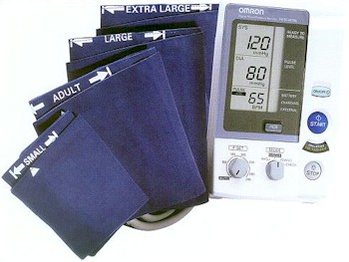
1. One Omron HEM907XL automated BP monitor.
2. BP cuffs in four sizes: S, M, L, XL
3. One Gulick II tape (or Gulick II Plus)
4. A chair with arm support for BP measurement, or a chair and table (table must provide for a comfortable resting posture of the arm with the cubital fossa at the level of the 4th intercostal space at heart level)
5. One black pen (marking on skin) and one No. 2 pencil (completing the form)

2.2 Exclusions

- Persons with rigid arteries such that an occlusion pressure cannot be reached. If the artery cannot be occluded before the mercury column reaches 300 mmHg, the participant is excluded.
- Persons with bilateral amputations of arms.
- Subjects who fit any of the above categories are recorded as missing data.
- If a subject has undergone a mastectomy of the right breast or has other reasons to omit right arm pressures, the left arm will be used for measures.

2.3 Set-Up Procedure
The proper cuff size must be used to avoid under- or over-estimation of BP. Cuff size refers to the cuff’s bladder, not the cloth. A copy of the chart below should be attached to the sphygmomanometer for easy reference. In addition, the cuffs must be HEM907 XL-compatible (see manual in Appendix). If the right arm cannot be used, the left may be used. This change must be noted on form.

- Determination of Cuff Size Based on Arm Circumference

 | Cuff Size | Arm Circumference |  | Bladder Size
 | Small Adult | 17-22 |  | Small
 | Adult | 22-32 |  | Medium
 | Large Adult | 32-42 |  | Large
 | Thigh | 42-50 |  | Extra Large

Measurement of arm circumference. The participant should remove his/her upper garment, or clear the upper arm area so that an unencumbered measurement may be made. The technician should:

- Have the participant stand, with the right arm hanging and bending the elbow so that the forearm is horizontal (parallel) to the floor.

- Measure arm length from the acromion (bony protuberance at the shoulder) to the olecranon (tip of the elbow), using the Gulick II anthropometric tape.

- Mark the midpoint on the dorsal surface of the arm.

- Have the participant relax arm along side of the body.

- Draw the tape snugly around the arm at the midpoint mark.
NOTE: Tape should be horizontal and should not indent the skin.

- Noting the arm circumference indicated by the tape, use the criteria above for determining cuff size.

Procedure

2.5.1 Wrapping the Blood Pressure Cuff around the Arm
The technician should:
1. Ensure the participant is seated, legs uncrossed, in a quiet room, with the elbow and forearm resting comfortably on the armrest of the BP measurement chair (or table), with the palm of the hand turned upward. The area to which the cuff is to be applied must be bare (free of clothing).
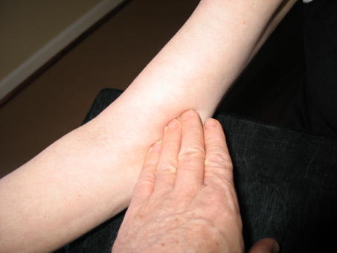
2. Locate the brachial artery by palpation and mark the skin with a small dot, using a black pen. (The brachial artery is usually found just medial and superior to the cubital fossa, posterior to the biceps muscle and slightly toward the body). For brachial artery palpation, fingertips or thumb may be used (see figures to the right).
3. Place the appropriate cuff around the upper right arm so that:
- The midpoint of the length of the bladder lies over the brachial artery.
- The cubital fossa is at heart level.

NOTE: The midpoint of the length of the bladder should be confirmed by folding the bladder in two. The marking on the cuff should not be trusted.
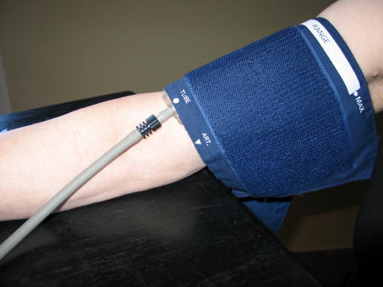

4. Place the lower edge of the cuff, with its tubing connections, about 1 inch above the natural crease across the inner aspect of the elbow (the cubital fossa).

5. Wrap the cuff snugly about the arm, with the palm of the participant’s hand turned upward, making sure the long edges of the cuff lie on top of each other as the cuff is wrapped around.

6. Secure the wrapped cuff firmly by applying pressure to the locking fabric fastener over the area where it is applied to the cuff.
NOTE: The cuff should not be wrapped too tightly around the arm.

General Guide to Blood Pressure Readings

- Following any previous inflation, wait at least 30 seconds after cuff has completely deflated.
- By closing the thumb valve and squeezing the bulb, inflate the cuff at a rapid but smooth continuous rate to the maximal inflation level (30 mmHg above systolic pressure). This measure is described in greater detail below.
- The examiner’s eyes should be level with the mid-range of the manometer scale and focused at the level to which the pressure will be raised.
- By opening the thumb valve slightly, and maintaining a constant rate of deflation at approximately 2 mmHg per second, allow the cuff to deflate.
- Listen throughout the entire range of deflation, past the systolic reading (the pressure where the first regular sound is heard) for 10 mmHg. Two subsequent beats should be heard for any valid systolic blood pressure reading.
- Deflate the cuff fully by opening the thumb valve.
- Neatly enter systolic readings in the spaces provided on the form.

2.5.4 Omron Technician
The Omron technician should:
1. Enter his/her Technician ID in the space provided at the bottom of the BCF form. Remove the standard cuff, after the RZ technician has completed the peak inflation level measurement, and apply the appropriate sized Omron cuff to the participant’s arm with the arrow at the brachial artery.
2. Turn on the Omron (It is best to have the Omron connected to the main power supply, rather than relying on the battery power). Turn the P-SET dial on the Omron to the P-Set level estimated in [2.6.3(7)], above. PLEASE NOTE: If using Omron equipment without prior Random Zero methods, enter the P-Set level as the pulse obliteration level + 30.
3. Turn the MODE on the Omron to MANUAL.
4. Place the double Y-stethoscope earpieces into his/her ears (at same time as other technician) and hold the bell over the participant’s artery.
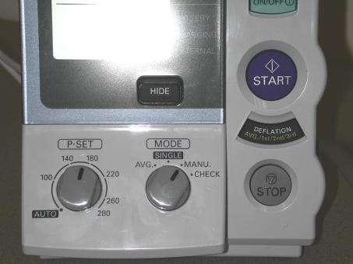
5. Press START on the Omron. The Omron will inflate the cuff for both devices.
6. Watch the Omron and listen for the onset of 1st (sounds) and 5th (disappearance) Korotkoff phase sounds, noting the pressure levels.
7. Record the systolic and diastolic BP levels from the Omron, when the cuff is completely deflated and the Omron is at “0.”

2.5.5 Second Blood Pressure Measurements

2.5.6 Measurements Using Omron Only Equipment

When taking measurements using ONLY the Omron equipment, follow all the instructions above for the Omron Technician except:

- only one technician is required
- Set the P-SET value to AUTOMATIC and record the maximum inflation on the monitor before the monitor begins automatic deflation as the P-set value.
- Set the MODE to AVG. The monitor will automatically take two measurements one minute apart displaying the first, second, and average blood pressure readings. Record each as directed in the SBP QxQs for the relevant items.

Quality Assurance

Training Requirements

Staff performing the ankle-arm index measurements should be research technicians or clinicians previously trained in taking research blood pressure measurements. In addition, training should include:

- Read and study manual
- Attend Jackson Heart Study training session on techniques (or observe administration by experienced examiner)
- Practice on volunteers
- Compare measurements with those made by experienced colleagues (Goal: obtain measurements within ± 2 mm Hg of that observed by a trainer)
- Discuss problems and questions with QC officer

Certification Requirements

- Complete training requirements
- Recite exclusion criteria
- Conduct exam on two volunteers while being observed by QC officer listening with Y stethoscope

Ankle/Brachial Systolic Blood Pressure Protocol

Purpose

The ratio of the ankle blood pressure to the arm blood pressure provides a measure of lower extremity arterial disease (circulation problems). The ankle-arm index (AAI) is reduced to less than 1.0 when there is obstruction to blood flow in the legs. The AAI is a non-invasive measure of atherosclerosis. The AAI is associated with atherosclerotic disease in other vascular beds and predicts cardiovascular mortality.

Equipment

- 8 megahertz Doppler pen probe with built-in speakers
- 9 volt alkaline batteries
- Doppler conducting jelly
- Standard mercury column sphygmomanometer: Wall-mounted Baumanometer
- Calibrated V-Lok BP cuffs in four sizes:
- 2 large adult cuff
- 2 small adult cuffs
- 4 regular adult cuffs
- 3 thigh cuffs
- Tissues to remove conducting jelly
- Black eyeliner pencil

Exclusions

- Persons with venous stasis ulceration or other pathology that precludes placing a BP cuff around the ankle (e.g. open wounds).
- Persons with rigid arteries such that an occlusion pressure cannot be reached. If the artery cannot be occluded before the mercury column reaches 300 mmHg, the participant is excluded.
- Persons with bilateral amputations of legs.
- Subjects who fit any of the above categories are recorded as missing data.
- If a subject has undergone a mastectomy of the right breast or has other reasons to omit right arm pressures, the left arm will be used for measures.

Set-Up Procedure

- Ask participant to remove shoes and stockings so that the ankles are bare to mid-calf.
- Participant is positioned on examination in a flat to semi flat position with trunk no more than 45 degrees from surface.
- Keep participant supine for at least five minutes before measuring BP.
- Place three BP cuffs on the participant (be sure to check for appropriate cuff size)
a) Right arm
b) Right ankle
c) Left ankle

If the right arm cannot be used, the left may be used. This change must be noted on form.

- Determination of Cuff Size Based on Arm and Ankle Circumference

 | Cuff Size | Arm and Ankle Circumference
 | Small Adult | < 24 cm
 | Adult | 24 to 32 cm
 | Large Adult | 33 to 41 cm
 | Thigh | > 41 cm

5. Apply ankle cuffs with midpoint of bladder over posterior tibial artery, with lower end of bladder approximately 3 cm above medial malleolus (prominence on medial side of ankle). See Figure 1.

Procedure

General Guide to Blood Pressure Readings

- Following any previous inflation, wait at least 30 seconds after cuff has completely deflated.
- By closing the thumb valve and squeezing the bulb, inflate the cuff at a rapid but smooth continuous rate to the maximal inflation level (30 mmHg above systolic pressure). This measure is described in greater detail below.
- The examiner’s eyes should be level with the mid-range of the manometer scale and focused at the level to which the pressure will be raised.
- By opening the thumb valve slightly, and maintaining a constant rate of deflation at approximately 2 mmHg per second, allow the cuff to deflate.
- Listen throughout the entire range of deflation, past the systolic reading (the pressure where the first regular sound is heard) for 10 mmHg. Two subsequent beats should be heard for any valid systolic blood pressure reading.
- Deflate the cuff fully by opening the thumb valve.
- Neatly enter systolic readings in the spaces provided on the form.

Right Arm Systolic Blood Pressure Measurement

- Attach right arm cuff tubing to manometer.
- Apply ultrasound jelly over brachial artery. The brachial artery is located just medial to the center of the cubital fossa.
- Locate brachial artery using Doppler pen probe.
- Hold the Doppler Probe absolutely still. It can easily slip off the artery.
- Measure the systolic blood pressure:
a. Inflate cuff quickly to maximal inflation level (30 mmHg above systolic pressure).
b. Deflate at 2 mmHg/second, to appearance of systolic pressure.
c. Follow down for 10 mmHg. Two subsequent beats should be heard for any valid systolic blood pressure reading.
d. Remove Doppler pen probe.
e. Deflate cuff quickly and completely.
f. Disconnect the right arm cuff from the manometer and connect to the right ankle cuff.
- Neatly record systolic blood pressure.
- Disconnect the right arm cuff from manometer.

Right and Left Ankle Systolic Blood Pressure Measurement

- Connect right ankle cuff to the manometer.
- Apply ultrasound jelly over posterior tibial artery. This artery is located on the calf and is most easily located at the medial malleolus of the ankle
- Locate posterior tibial artery using Doppler pen probe.
- Hold the Doppler probe absolutely still. It can easily slip off the artery.
- Measure the systolic blood pressure:
a. Inflate cuff quickly to maximal inflation level (30 mmHg above systolic pressure).
b. Deflate at 2 mmHg/second to appearance of systolic pressure.
c. Follow down for 10 mmHg. Two subsequent beats should be heard for any valid systolic blood pressure reading.
d. Remove Doppler pen probe.
e. Deflate cuff quickly and completely.
- Neatly record ankle systolic blood pressure.
- Disconnect right ankle cuff from manometer. Connect left ankle cuff to manometer and repeat procedure.

NOTE: If the posterior tibial pulse cannot be found with palpation or Doppler pen probe, use the dorsalis pedis artery for the measurement. Have another examiner verify the absent posterior tibial pulse.

- Right and Left Ankle Cuff Placement

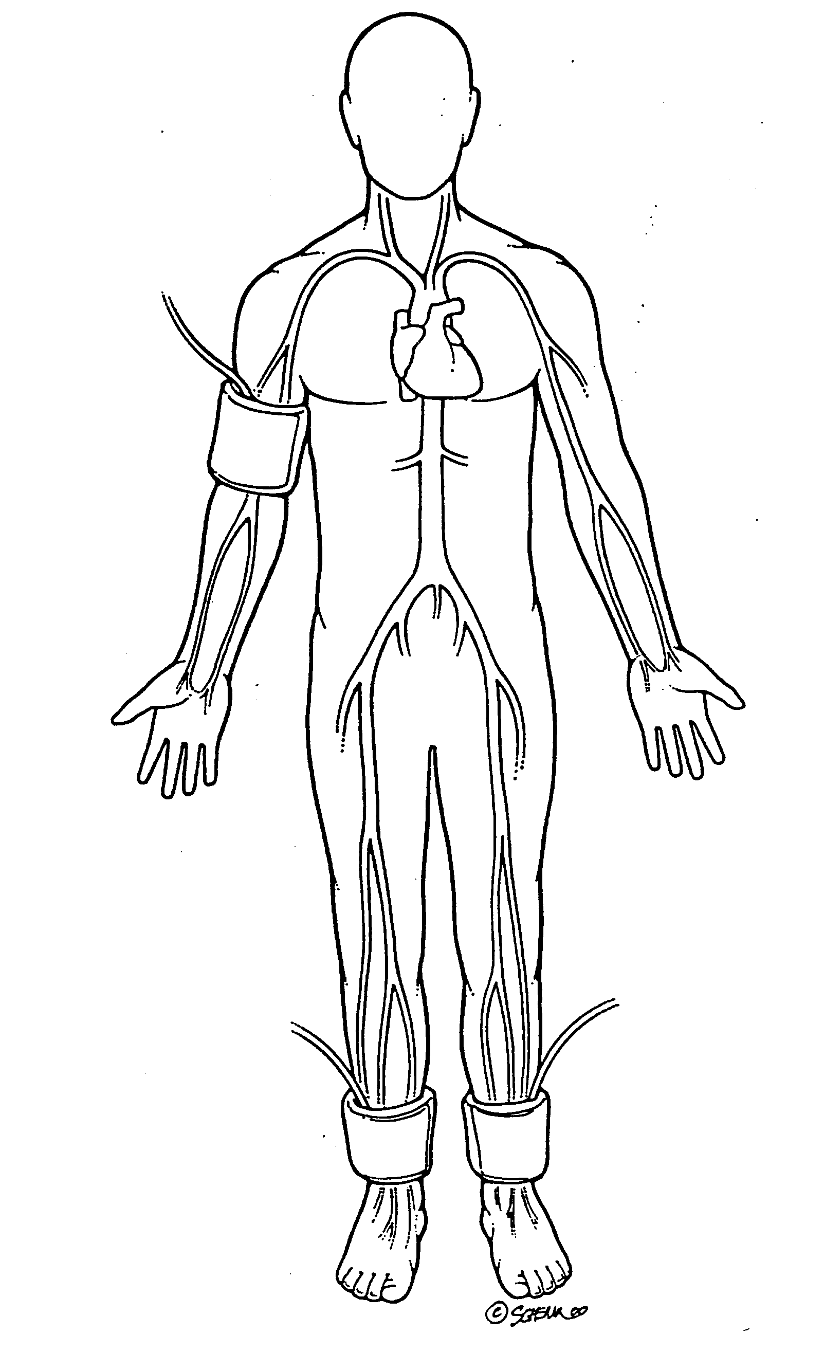

Repeating the Ankle-Arm

Repeat the sequence in reverse order
a. left ankle
b. right ankle
c. right arm

Tips for Ankle-Arm Measurements

Using the Doppler

Push button in to turn on and gradually turn the volume up. Now place the probe over the artery (brachial or posterior tibial).

The frequency used is 8 Megahertz (vibrations of 8 million times per second). In order to hear the signal above background noise, the instrument must be pushed in toward the artery. Angling the beam upstream improves the signal. For deeper vessels, the unit will have to be tilted back toward perpendicular, but NOTE: the instrument works poorly or not at all if held fully perpendicular to the flow. It must always be angled into and IN LINE with the flow. Please see figure below.

- Doppler Probe Position

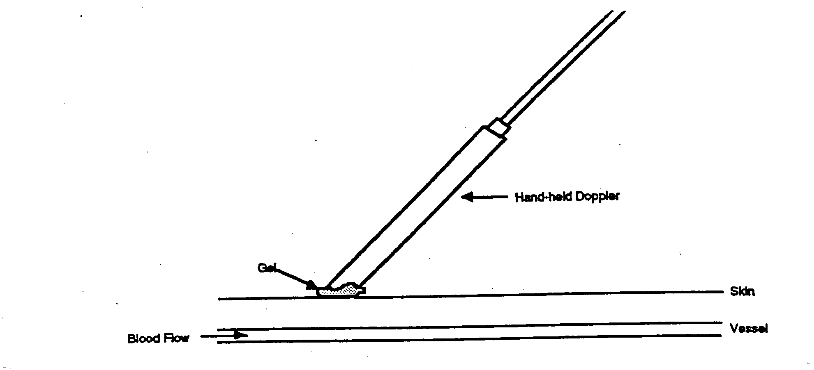

In some places along the posterior tibial artery, there is anatomical hiding of the vessel by muscle or tendons. Move up or down the vessel a little to find the best signal above background noise.

The purpose of the Doppler is to determine that blood is or is not flowing under the cuff. For correct interpretation, the probe MUST be centered directly over the artery and must not be moved while inflating the cuff.

Please note that the Doppler unit turns itself off after 5 minutes automatically. This may occur in the middle of a measurement.

- Mark the location of maximal pulse or Doppler signal on the brachial artery and both posterior and tibial arteries with eyeliner pencil to improve the speed and accuracy of localizing them the second time and to help maintain position.

- Hold the Doppler pen absolutely still while inflating and deflating the cuff; moving a few millimeters will lose the pulse.

- Always use enough jelly to ensure good contact.

Maintenance of Doppler

- KEY POINT: Use only ultrasound gel

- The probe: The probe consists of two crystals; one for transmitting the ultrasound waves and the other for receiving the reflected waves. If either crystal is damaged, the probe will not work properly or will not work at all. The crystals are covered by epoxy resin. This resin is attacked by any gel or liquid containing the chloride ion. Therefore, NEVER use ECG paste or cream as the contact medium between the skin and the crystals. Use AQUASONIC or any gel made for ultrasonic physical therapy equipment. In an emergency use any surgical jelly or lubricant, even Vaseline or mineral oil. Remove the gel after use with a soft tissue. If the probe has dried gel on it, wash it off under running water. Do NOT scrape off the gel because this may damage the epoxy coating. Do NOT autoclave the probe. Gas sterilization is OK.

- KEY POINT: To preserve the battery, turn off the unit immediately after measurements.

- The battery: As the battery runs down, the signal will get weaker to the point where the instrument just doesn’t work. Most batteries run down because the instrument has been left turned on. It takes less than a minute to make a blood pressure measurement. Turn the unit off immediately after removing it from the skin. Use an alkaline-type replacement 9-volt transistor radio battery.

- Abnormal Doppler Noise: On occasion there are unusual noises from the Doppler that do not indicate a problem with the Doppler. The normal sound will become obvious with experience in performing this test. Following are some common complaints and their causes.

- Popping noises when the probe is first placed on the skin. Scratchy sound at first. Cause: bubbles in the gel that are moving and/or popping. Also hair movement can cause noise. Remedy: Use a new glob of gel that looks clear, push down enough so hair is immobilized, and just wait a few seconds for things to settle down. If the noise isn’t there when the probe is clean (no gel) and suspended in the air, the Doppler and/or probe are probably not at fault.

- Bad static when the dry probe is moved in the air. Cause: a loose connector where the probe connects to the instrument, a broken shield wire in the cable either at the connector or as it comes out of the probe. This can be diagnosed by wiggling the wire or connectors gently. There is NORMALLY some static generated when the cable is flexed, but it isn’t severe. Remedy: QC Officer will arrange to replace probe or get connectors fixed.

- High-pitched tone. Cause: radio interference from a mobile service, police station nearby, even another Doppler working nearby. Usually occurs near large open windows, rarely in the center of the building. Remedy: Move to another room.

- Howling noise when the probe with gel on it is held or laid on a table. Cause: acoustic feedback through the probe acting as a microphone. If it doesn’t occur without gel on the probe, everything is OK.

Guidelines for Blood Pressure

a. Determining the Maximal Inflation Level (MIL)

Determine the pressure to which to inflate the cuff for the measurement of the systolic blood pressure. This assures that the cuff pressure at the start of the reading exceeds the systolic blood pressure and allows you to hear the first Korotkoff sound. The maximal inflation level (MIL) should be measured specifically for the ankle-arm index measurement, using the Doppler, independently from its measurement for the regular blood pressure measurement. The procedures for determining MIL are as follows:

- Attach the cuff tubing on the arm to the conventional mercury sphygmomanometer.

- Locate the brachial pulse with the Doppler.

- Inflate the cuff until the brachial pulse is no longer heard.

- Deflate the cuff quickly and completely.

- Inflate the cuff to 30 mmHg above the Doppler systolic pressure for all subsequent readings.

- Repeat the MIL if the first attempt was unsatisfactory or you have had to readjust the cuff after measuring the MIL. Wait 30 seconds before making a second attempt if the first is unsatisfactory.

- If the brachial pulse is still heard at a level of 270 mmHg or higher (which means that the MIL is 30 mmHg or higher) repeat the MIL. If the MIL is still 300 mmHg, terminate the blood pressure measurements and write in “300/MIL” on the form. On the Report of Findings, indicate the blood pressure at the level heard. Refer the participant to see their doctor based on the blood pressure taken with a stethoscope. The Doppler will always be higher.

b. The systolic value is the pressure level at which you hear the first of two or more swishing sounds in the appropriate rhythm. (Note: A single sound heard in isolation [i.e., not in rhythmic sequence] before the first of the rhythmic sounds [systolic] does not alter the interpretation of blood pressure).

c. Record all readings to the nearest even digit, rounding up (i.e., read any value that appears to fall exactly between the markings on the mercury column to the next higher even marking).

d. Make readings at the top of the meniscus, or rounded surface of the mercury columns.

e. When the pressure is released too quickly from a high level, a vacuum is formed above the mercury and the meniscus is distorted. Allow a few moments for it to reappear before reading the manometer or doing a repeat measurement.

Quality Assurance

Training Requirements

Staff performing the ankle-arm index measurements should be research technicians or clinicians previously trained in taking research blood pressure measurements. In addition, training should include:

- Read and study manual
- Attend Jackson Heart Study training session on techniques (or observe administration by experienced examiner)
- Practice on volunteers
- Compare measurements with those made by experienced colleagues (Goal: obtain measurements within ± 2 mm Hg of that observed by a trainer)
- Discuss problems and questions with QC officer

Certification Requirements

- Complete training requirements
- Recite exclusion criteria
- Conduct exam on two volunteers while being observed by QC officer listening with Doppler

Appendix 3 Check Procedures for Maintenance of the Omron HEM907XL Blood Pressure
Equipment

The following checks should be conducted at least every month, and a log kept of the dates and the people carrying out the troubleshooting (see Appendix 4).

1. Assemble the following equipment:
2. Connect the manometer, inflation bulb, cuff, and the monitor with the T-tube (see p 26 of the Omron HEM907XL Instruction Manual.
3. Tightly wrap the cuff over a sturdy cylinder
4. Release the valve of inflation bulb to remove the air inside the cuff completely
5. Set the MODE to “CHECK”
6. Close the valve of inflation bulb and inflate the cuff to the pressure to be checked, based on the manometer read
7. Compare the pressure values displayed on the monitor with the one on the manometer

CHECK RESULT: The accuracy of the monitor should be validated to ±3 mmHg or 2% of standard manometer reading. If the result shows a difference exceeding this tolerance, contact Omron repair department (1-877-216-1336).

Appendix 4 Checklist for Biannual Observation of BP Technicians by BP Supervisor

BP Technician Code #_______ Observer Code #_______

Date Observed ____/____/_____

_______________________________________________________________________

Instructions: For each item, check "yes" or "no" in the space provided to indicate if the procedure is carried out correctly. Record any comments in the blank line between that item and the next. For certain items specific parts of the procedure which are important are listed separately. Supervisor should recheck all measurements and procedures.

 | Yes | No
ALL:
Measures arm for correct cuff size | ( ) | ( )
Palpates brachial artery | ( ) | ( )
Marks pulse point | ( ) | ( )
Wraps cuff center of bladder over brachial pulse | ( ) | ( )
Leaves subject for five minutes rest | ( ) | ( )
Instructs on Posture | ( ) | ( )
Full five minutes for rest allowed | ( ) | ( )
Work station free of excessive noise | ( ) | ( )
Explanation | ( ) | ( )
Calculates peak inflation, standard manometer | ( ) | ( )
Calculates peak inflation, R-Z | ( ) | ( )
If computer is down use the formula (pulse obliteration pressure + R-Z maximum zero number + 30
Explanation | ( ) | ( )
Connects R-Z tube to cuff | ( ) | ( )
Sure reservoir lever open (newer devices have no lever) | ( ) | ( )
Opens bellows valve and waits full 3 seconds for mercury to settle | ( ) | ( )
Turns thumb wheel (down strokes only) | ( ) | ( )

 | Yes | No
Informs participant of average readings | ( ) | ( )
OMRON
Assure unit is properly plugged into wall unit | ( ) | ( )
Push ON/OFF button to turn on power | ( ) | ( )
Set the MODE for AVG (if off site)  Set the MODE for MANU if on site | ( ) | ( )
Set the P-SET to AUTO (if off site)  Set the P-SET to = Item 15 SBP-B (if on site) | ( ) | ( )
Wrap the proper size cuff on arm | ( ) | ( )
Press the START button to take measurement | ( ) | ( )
Records the first measurement | ( ) | ( )
Records the second measurement | ( ) | ( )
Records the average measurement (if off site) | ( ) | ( )
Push the ON/OFF button to turn the power off | ( ) | ( )
Inform the participant of the average reading | ( ) | ( )
Special Comments:

______________________________________________________________________________

______________________________________________________________________________

______________________________________________________________________________

Appendix 5 JHS Monthly Log for Sitting Blood Pressure Station
This needs revisions to reflect Omron maintenances

Month________Year________

Weekly Check Procedures:
 |  |  |  | Week
 |  | 1 | 2 | 3 | 4 | 5
1. | Date of Check
 |  | _____ | _____ | _____ | _____ | _____
A. | Check Tube for Oxide Dust | _____ | _____ | _____ | _____ | _____
B. | Check Cap for Tightness | _____ | _____ | _____ | _____ | _____
C. | Check Omron for Accuracy | ______ | _____ | ______ | ______ | _____

Procedures performed only if there appear to be problems:

C. If mercury bounces even though the cap appears tight, remove cap, clean of any mercury beads, and check opening at top of tube for dust

 | Check Needed and Performed during weeks | 1 | 2 | 3 | 4 | 5
 | (Circle number of weeks applicable)

D. If tube appears "dirty" (oxidized mercury) remove cap, tip manometer to retract mercury, run pipe cleaner down, replace cap

 | Needed and Performed during weeks | 1 | 2 | 3 | 4 | 5
 | (Circle number of weeks applicable)

E. List the problem encountered, the date, and the actions taken below:

_________________________________________________________________________

_________________________________________________________________________

_________________________________________________________________________

Monthly Check Procedures:

A. Accuracy Check on Random-Zero Sphygmomanometer (to be performed every 2 months):

B. Standard sphygmomanometer check (to be performed every two months)

Date of check: ______________

A. Check cap for tightness ______

B. Check tube for oxide dust ______

C. Check that mercury is at
zero with no pressure ______

List any problems found and corrective action taken:

_________________________________________________________________________

_________________________________________________________________________

_________________________________________________________________________

C. Accuracy check for Omron monitor (to be performed every two months)

Date of Check: ________________________

Problems found on accuracy check? ( ) Yes ( ) No

If yes, list problems found and corrective action taken:

_________________________________________________________________________

_________________________________________________________________________

_________________________________________________________________________
D. Measuring tape for arm circumference worn or stretched

Tape measure has been tested as part
of Anthropometry station procedures. ( ) Yes ( ) No

If no, perform tape measure calibration check:

Check by holding the zero mark of the tape against the ruler used to measure standing height at the 150 cm. mark. If the 30 cm. mark on the tape used for arm circumference falls outside the range 119.5 to 120.5 on the standing height ruler it should be replaced.

Date of check: _____

Point on height ruler where 30 cm. on tape falls _____

Appendix 7 Form for Recording Simultaneous Blood Pressure Observations on a Volunteer by Two Technicians

this section needs to be revised to reflect BP observation for OMRON only. There are components that reference random zero techniques.

Instructions:

Biannually, each technician should be part of a pair of technicians who simultaneously measure blood pressure using an Y-tube on a volunteer (not a JHS participant). Each technician should separately record his/her measurements on a standard paper JHS SBP form. The blood pressure supervisor should then transfer the results to this form and calculate the differences between the two sets of measurements. If the difference on any individual measurement is greater than 4 mmHg, or if the averages of the two readings for each technician differ by more than 3 mmHg, the supervisor should indicate the corrective action taken on this form. Any further sets of simultaneous measurements for a given pair should appear on a new form.

Technician IDs: 1st ID: __________ 2nd ID:__________ Date: _______

 |  | 1st Technician | 2nd Technician | Difference
a. | Initial arm circumference (cm) | ___________ | ___________ | ___________
b. | Initial cuff size selected | ___________ | ___________ | ___________
c. | Pulse Obliteration Pressure | ___________ | ___________ | ___________
d. | First SBP | ___________ | ___________ | ___________
e. | First DBP | ___________ | ___________ | ___________
f. | First Zero Reading | ___________ | ___________ | ___________
g. | First Net SBP  Corrected for Zero | ___________ | ___________ | ___________
h. | First Net DBP  Corrected for Zero | ___________ | ___________ | ___________
i. | Second SBP | ___________ | ___________ | ___________
j. | Second DBP | ___________ | ___________ | ___________
k. | Second Zero Reading | ___________ | ___________ | ___________
l. | Second Net SBP  Corrected for Zero | ___________ | ___________ | ___________
m. | Second Net DBP  Corrected for Zero | ___________ | ___________ | ___________
n. | Average Net SBP | ___________ | ___________ | ___________
o. | Average Net DBP | ___________ | ___________ | ___________

ACTION TAKEN IF DIFFERENCES BETWEEN TECHNICIANS EXCEED LIMITS SPECIFIED:

______________________________________________________________________________

______________________________________________________________________________

______________________________________________________________________________

______________________________________________________________________________

______________________________________________________________________________

 | Omron Technician
1 | Apply the Omron appropriate sized cuff to the participant’s arm with the arrow at the brachial artery (same size used during the core exam Blood Pressure measurement).
2
3 | Turn on the Omron. Turn the P-SET dial on the Omron to the P-Set level estimated in #5 (RZ) above. Turn the MODE on the Omron to MANUAL.
4 | Place the double Y-stethoscope earpieces into ears, holding the bell over participant’s artery.
5 | Press START on the Omron, cuffs will inflate.
6 | Watch the Omron.
7 | Listen for the onset of 1st (sounds) and 5th (disappearance) Korotkoff phase sounds.
8 | When the cuff is completely deflated and the Omron is at “0,” record the systolic and diastolic BP levels from the Omron (Item 24 for 1st reading).
9

Appendix 9
OmROn®
INSTRUCTION MANUAL
IntelliSenseTM Blood Pressure Monitor Model HEM907XL

Table of Contents
Be Sure to Read This Section
Exemptions 2
Notes on Safety 3
Know Your Unit
Features of the Product 7
Components of the Product 8
Options 9
Features and Functions 10
Names of the Parts 10
Functions and setting
while the unit is in use 12
Preparations before Measurement
How to Apply the Cuff 14
How to Use the Power Source 16
How to Use the AC Adapter 16
Installation and Replacement
of Battery Pack 17
How to Measure Blood Pressure
List of Measurement Modes 19
SINGLE Mode 20
AVG Mode 22
MANU Mode 24
How to Check Pressure Accuracy. .26
How to Clean the Unit after Use 27
List of Error Codes 28
Troubleshooting 29
Specifications
Caution 30
Five Year Limited Warranty 31
Specifications 31
Please keep this manual near the monitor all the time for future reference.

Please thoroughly read this Instruction Manual before using this monitor to ensure safe and accurate use.

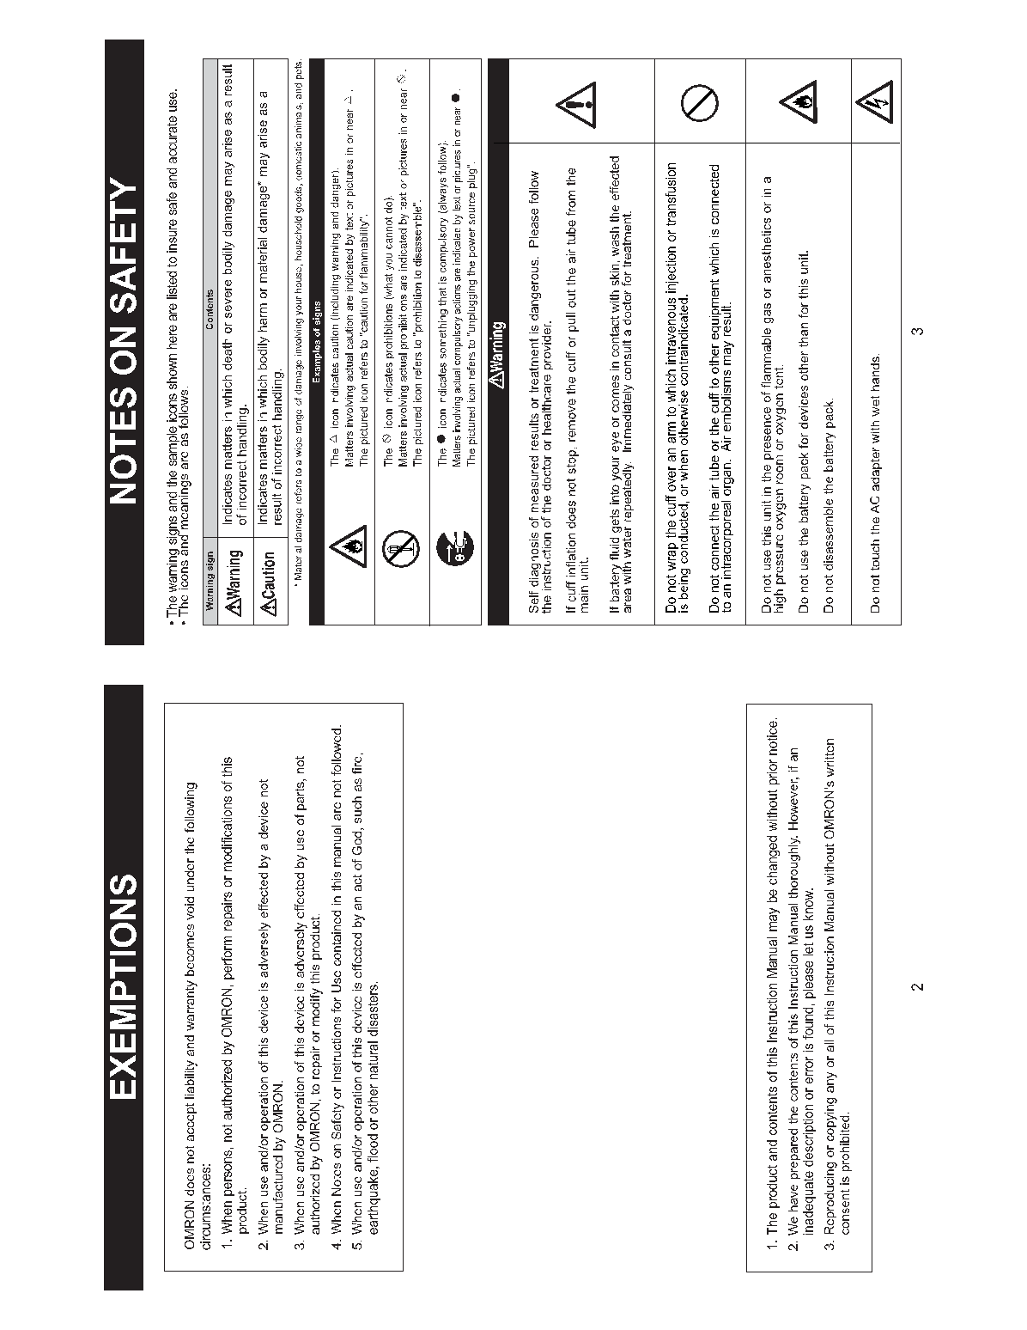



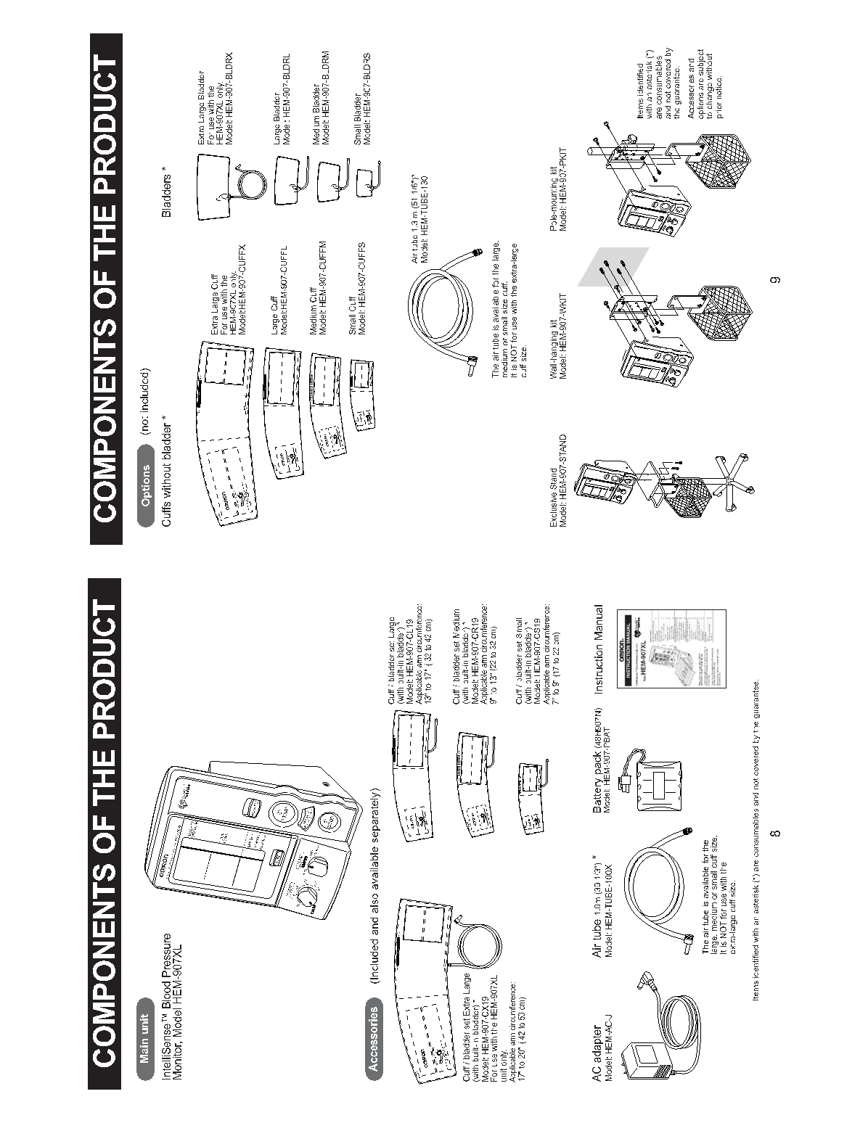

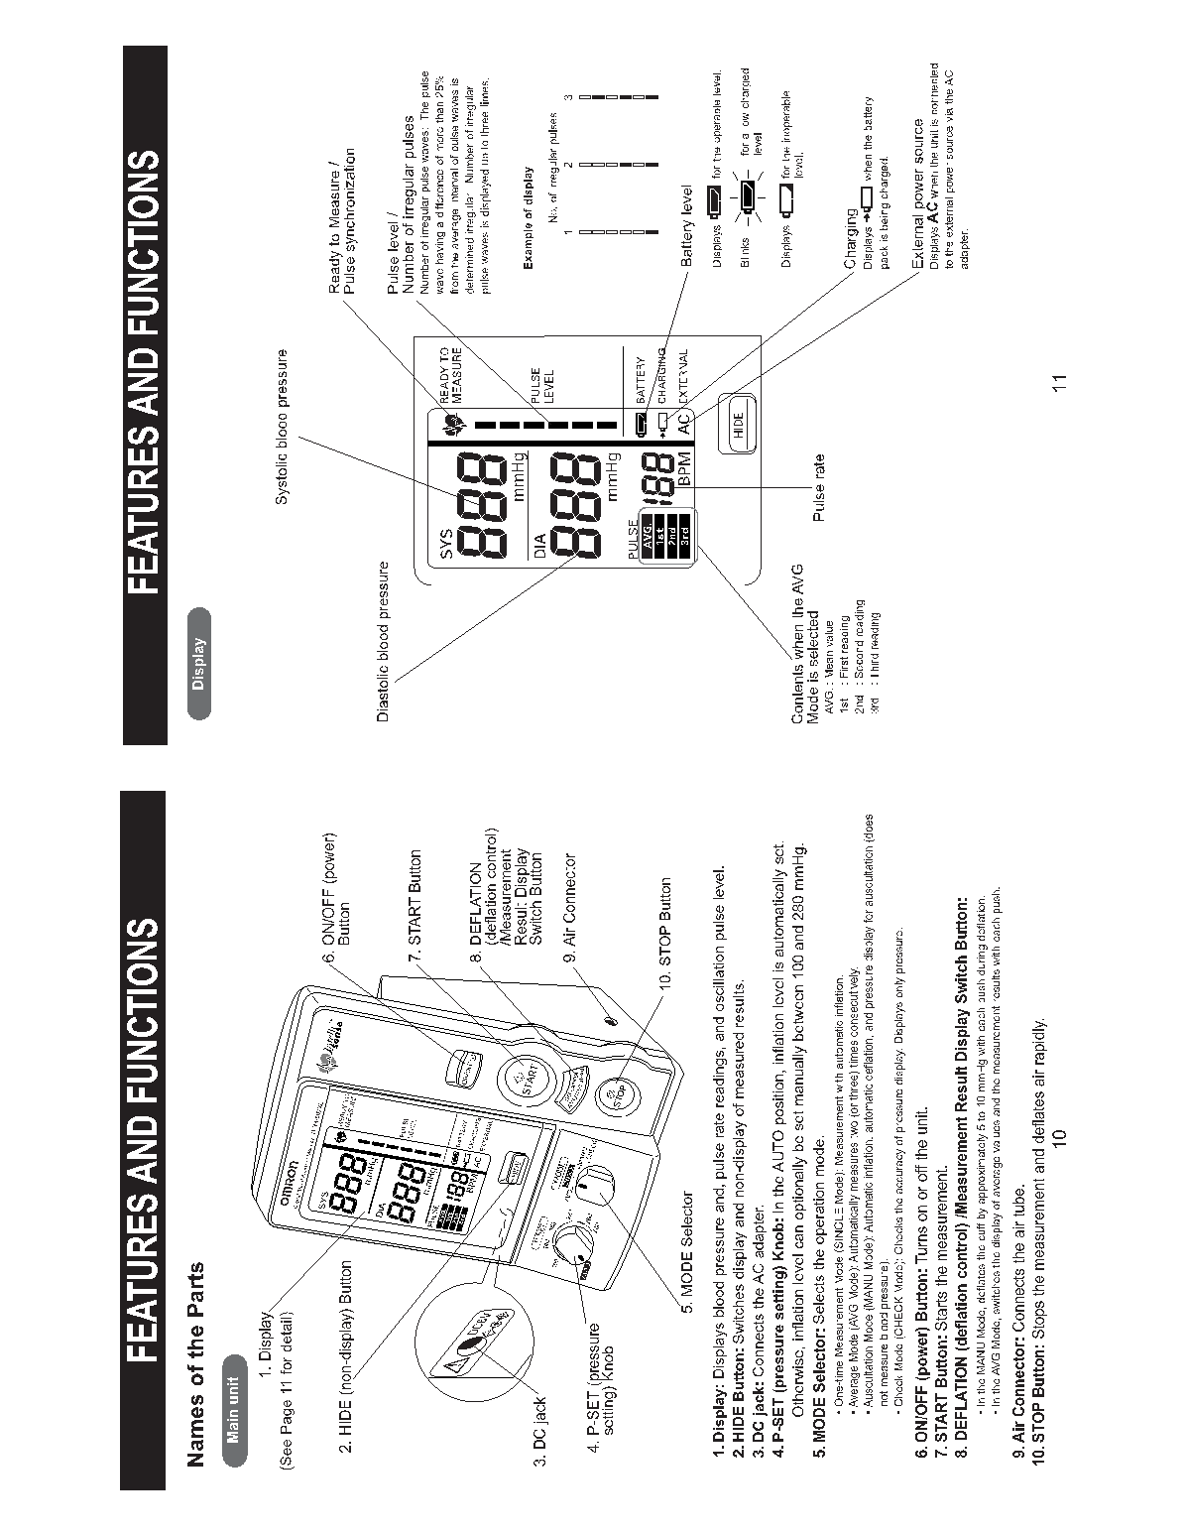

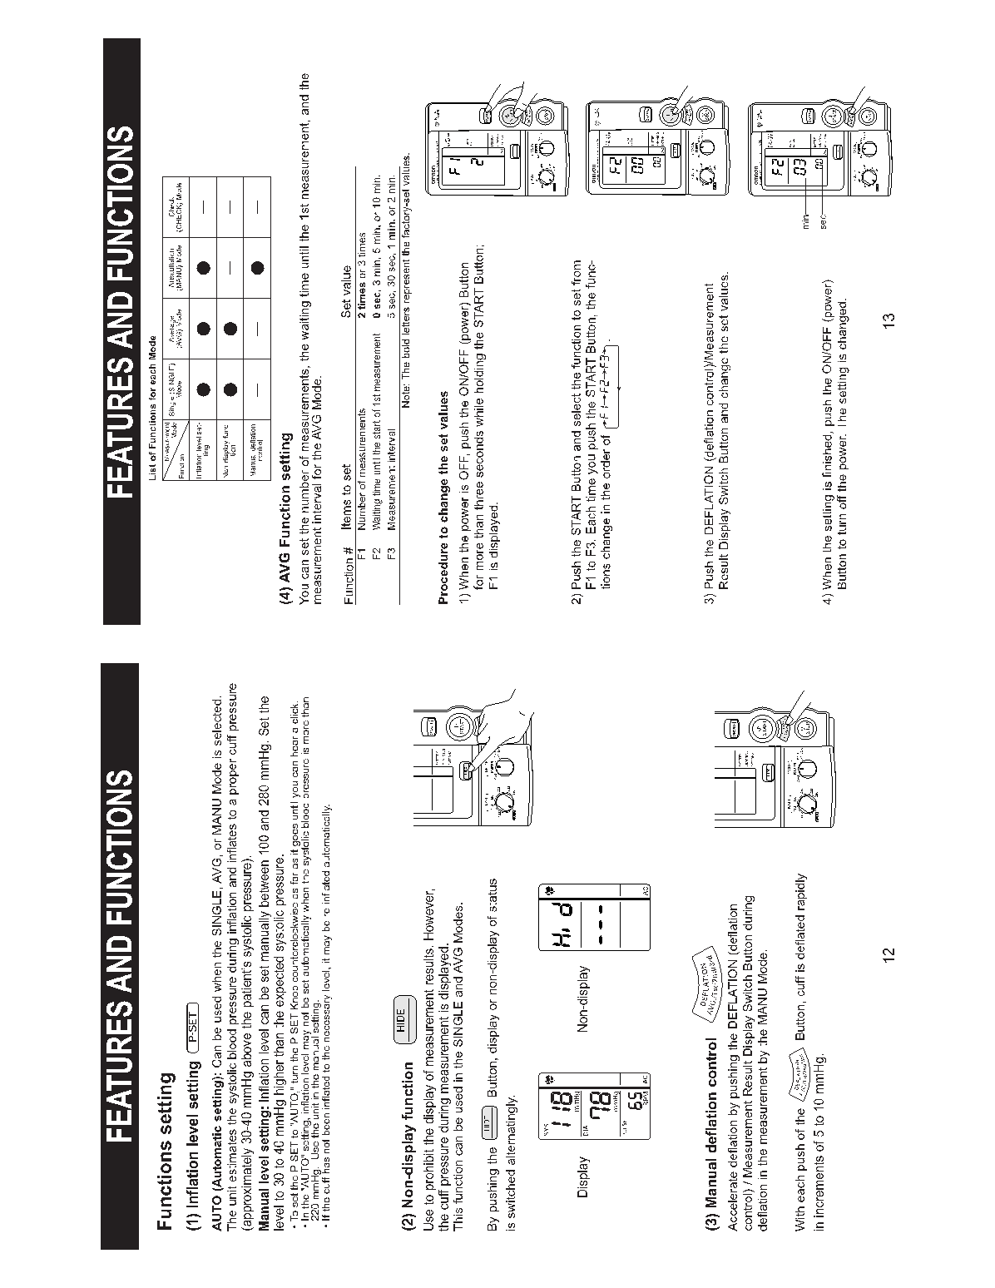

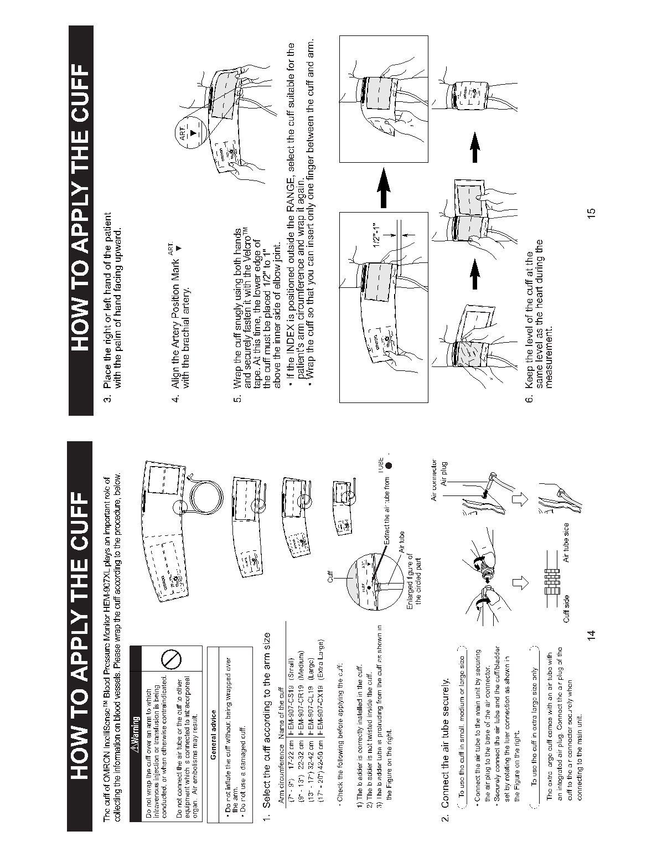

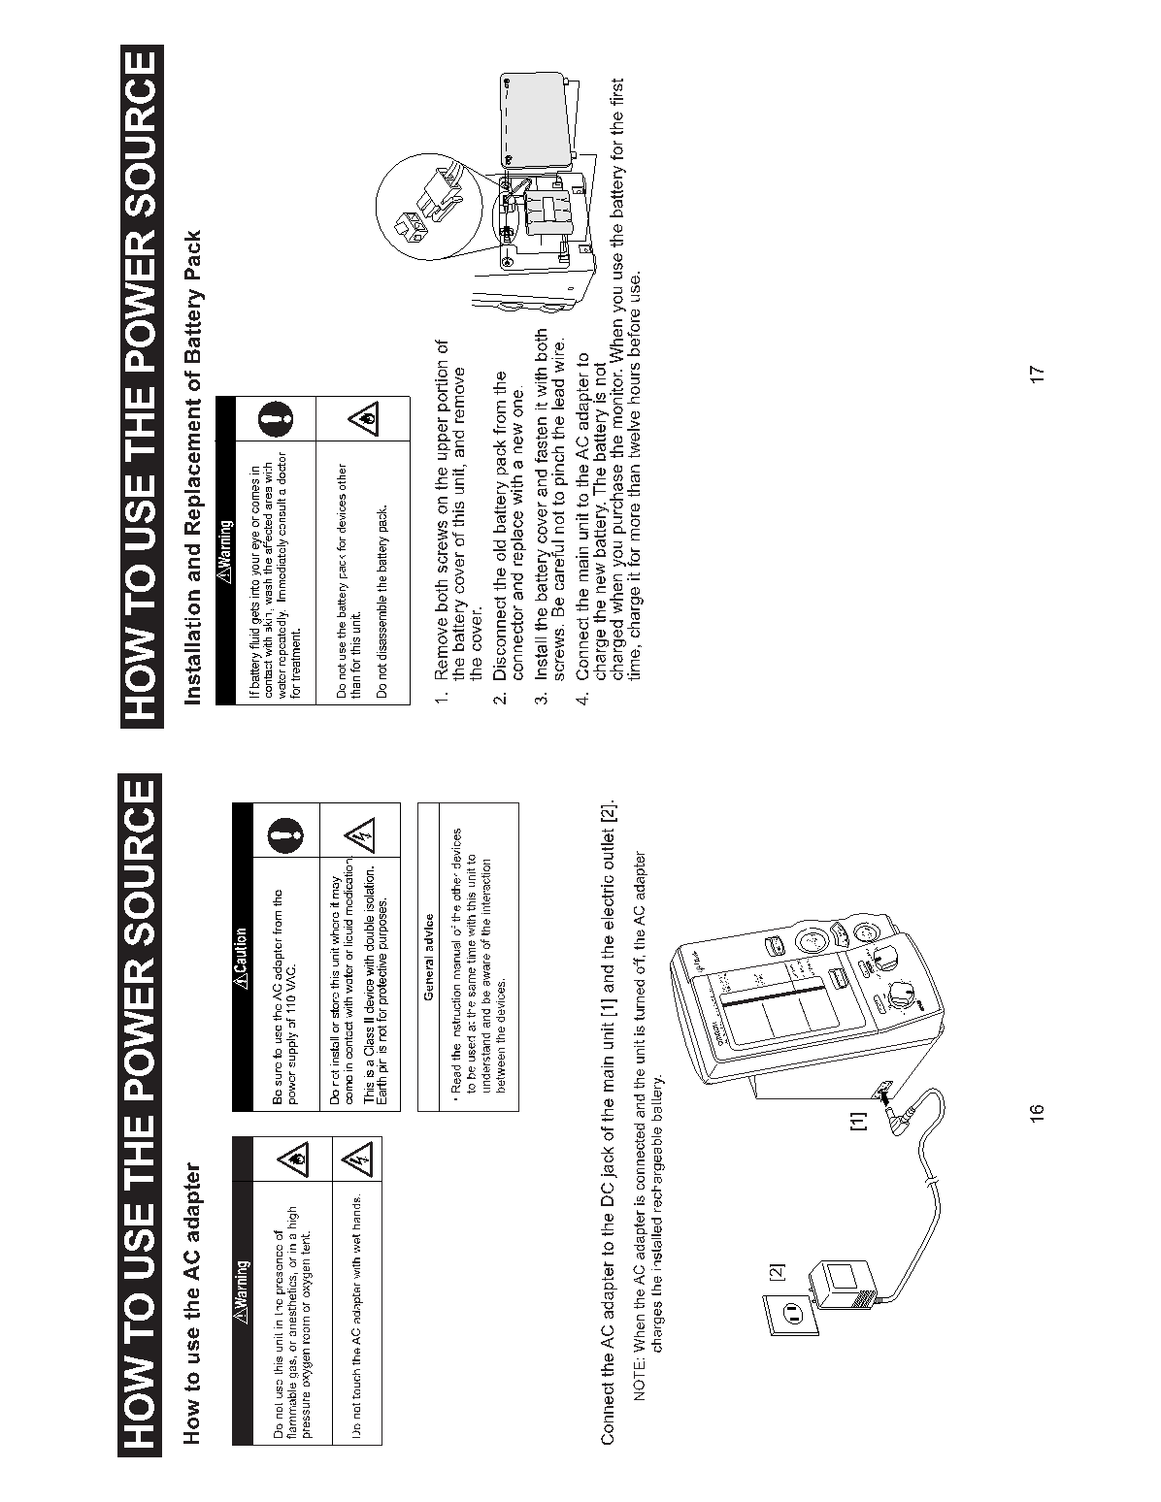

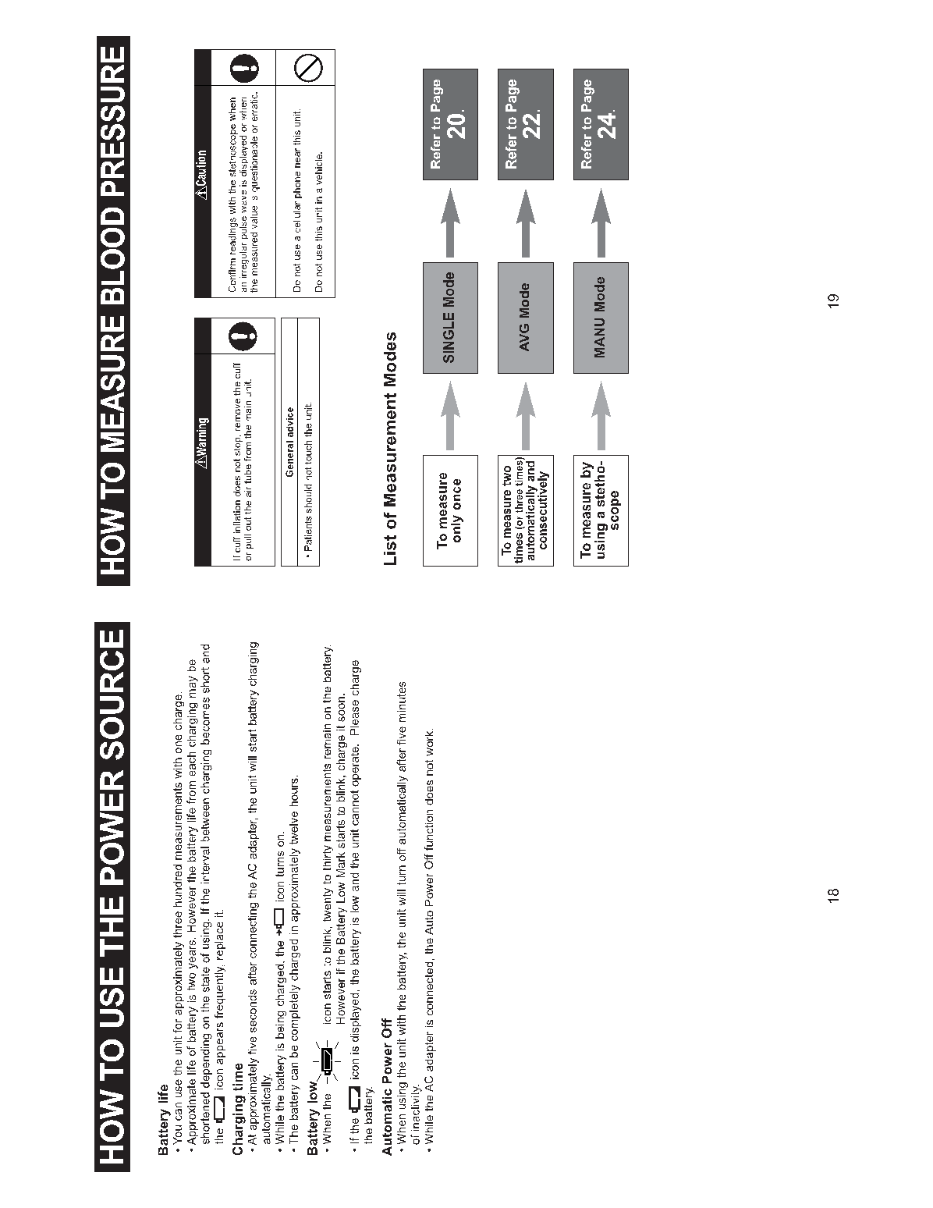

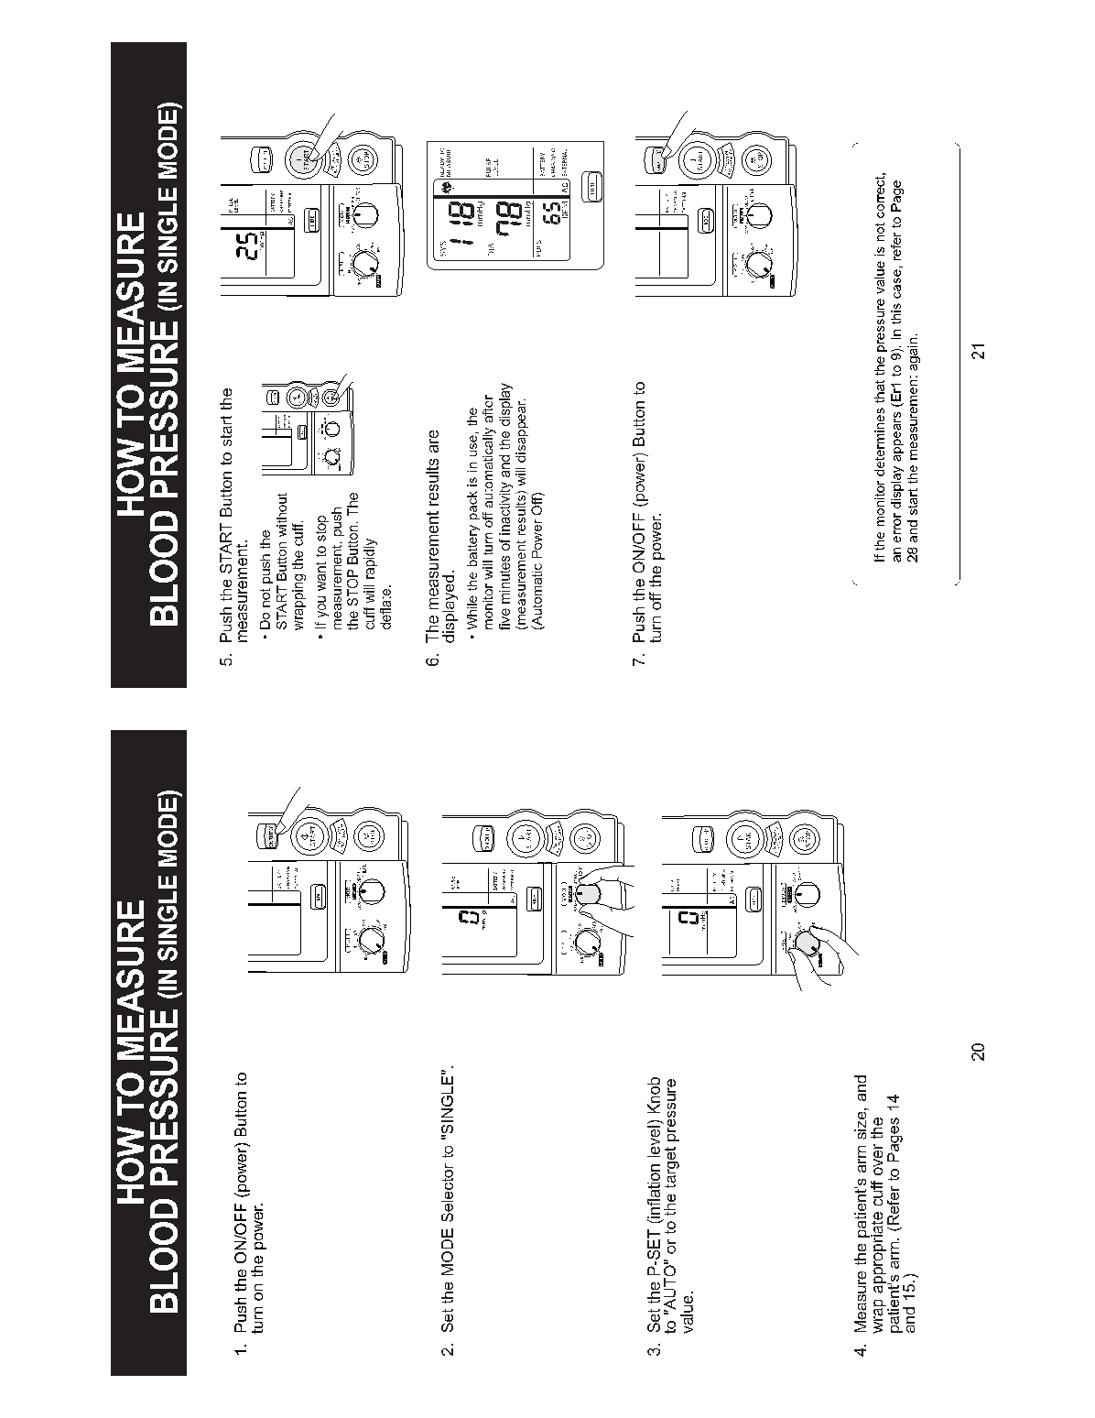
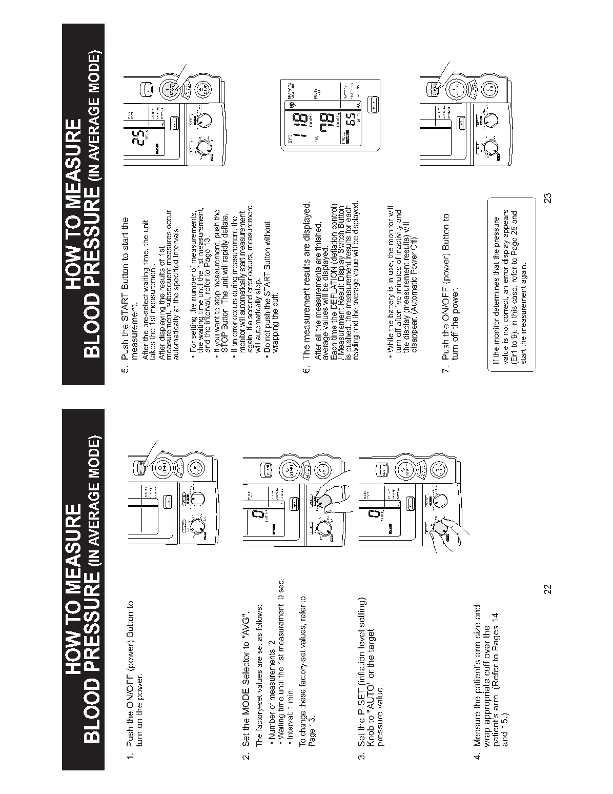
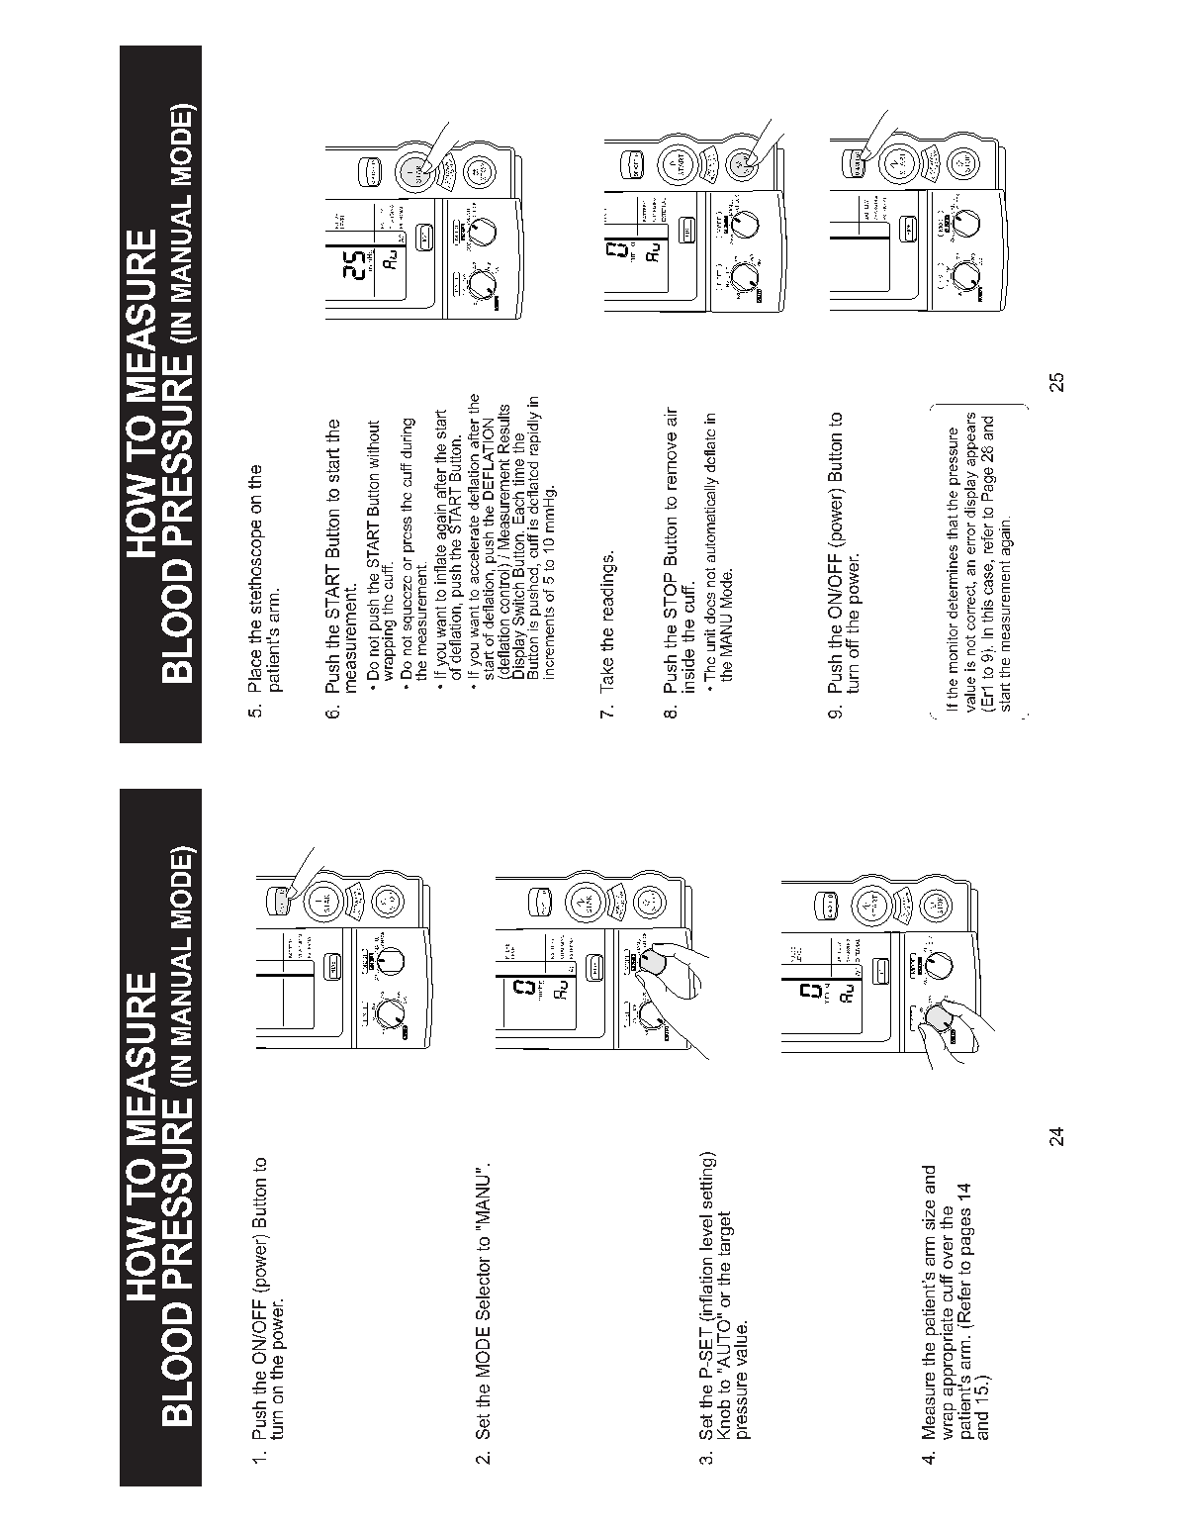

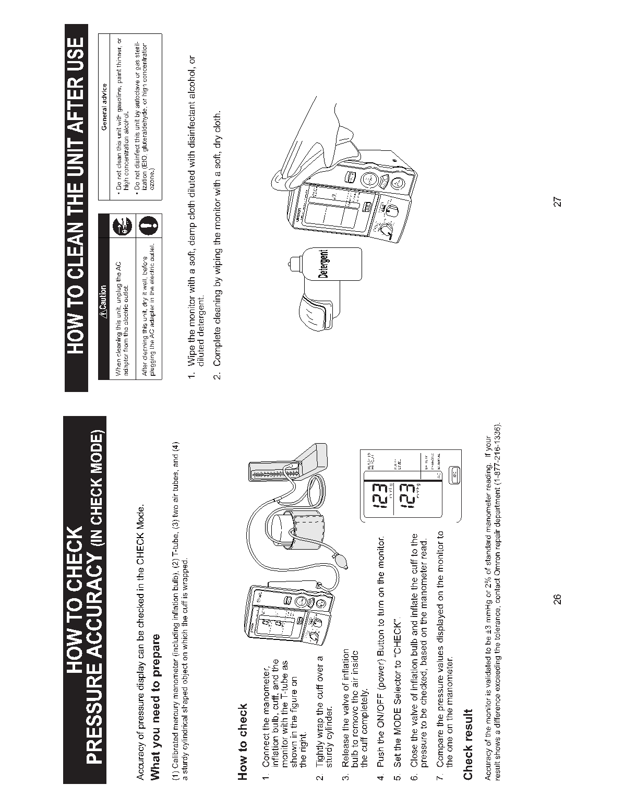
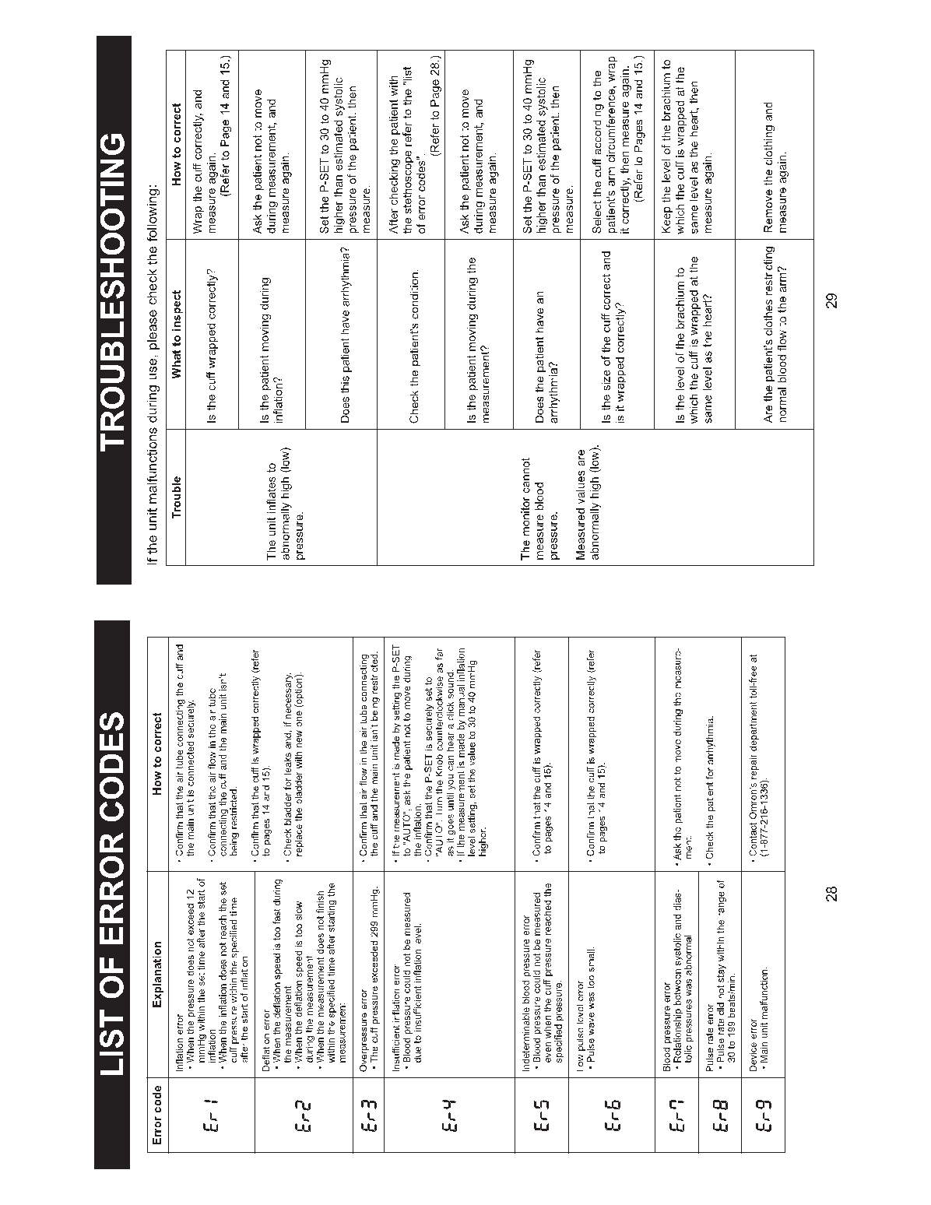

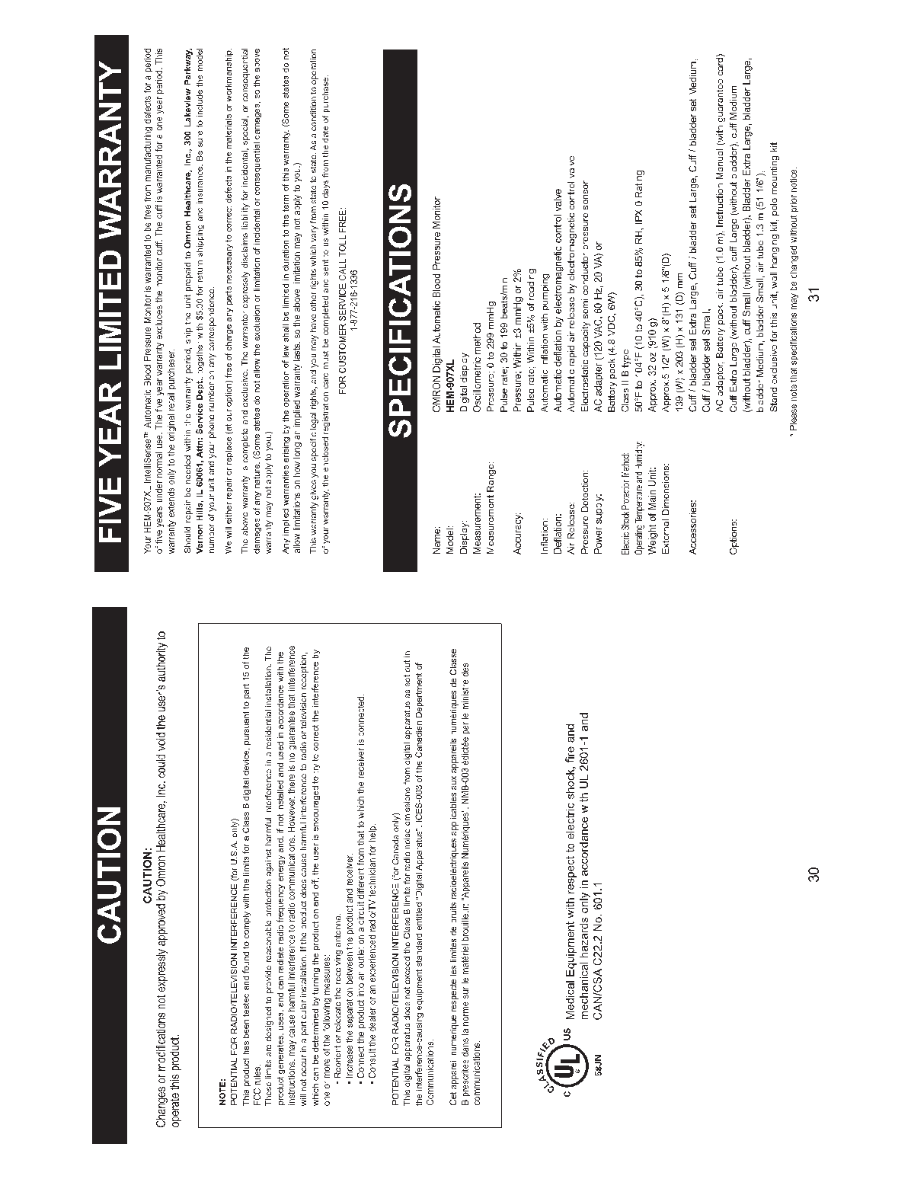


Appendix 10 Omron HEM-780 Instruction Manual

